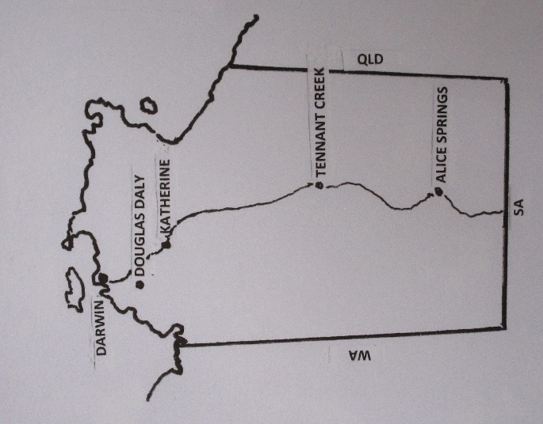
2020 Top End
AA Events

Darwin Unity Weekend
With Al-Anon participation
July 31-August 2, 2020
Theme: “A Fellowship of Friends”

Darwin AA members welcome you to this simple, laid-back weekend where Groups hold their regular meetings over the three days with some extra meetings thrown in.

Fire up your weekend at the Friday night meeting of the Casuarina Group (which actually meets at Rapid Creek). Female members welcome to the Saturday morning Women’s Recovery Group meeting at Nightcliff Primary School while all members can come to the lunchtime meeting on the verandah outside our District Office at Bauhinia St, Nightcliff. If you fancy a compact ID meeting that evening, the Saturday Nightcliff Group meets for an hour from 7.30pm at the same place. Don’t worry – we’ll put out a program before the weekend.
Barbecue dinner followed by
a meeting, auction and dance
Starting at 6.00pm on Saturday with a barbecue at a member’s place (19 Mary St, cnr Charles St, Stuart Park is the address) there’s a meeting at 8.00pm. Feel welcome because this evening was a blast last year - like you usually only get to dance at a national convention!
Breakfast by the lake
Next morning enjoy a Spiritual Concepts meeting after a breakfast of bacon and eggs under shady trees bordering Lake Alexander at Darwin’s East Point. Rock up around 8.00am, meeting starts 9.00am. After digesting that meeting, take a run out to Darwin’s rural area for the 2.00pm Humpty Doo meeting. Then close the day at the 7.00pm Living Sober meeting in the city.

Need help? For AA: Terry B - 0418 895 007, Bill H - 0417 816 278, Marg M - 0402 602 602,
Mark P - 0400 255 019. For Al-Anon: Sarah A - 0407 013 395
For more information and updates on the program and on things you might like to do during the week between the Bill W Camp and this Weekend….
www.aadarwin.org.au
Do book accommodation early because this is the Darwin Cup weekend. Katherine Roundup continues the fellowship the following weekend - August 7-9.
“…an understanding that is indescribably wonderful” – Big Book P17

