GENERAL SERVICE
CONFERENCE TOPICS
2023

ALCOHOLICS ANONYMOUS AUSTRALIA

Topics
Introduction 2
TOPIC #004/2023: (Gender- neutral 12 Step banners for meetings) 3
TOPIC #007/2023: (Standardised interim financial reporting) 6
TOPIC #008/2023: (Members who do not identify as human) 8
TOPIC #009/2023: (Raise the profile of the 12 Concepts) 9
TOPIC #010/2023: (Video/audio summary/podcast of conference highlights) 10
TOPIC #011/2023: (Rewrite/update the Australian Service Manual) 11
TOPIC #013/2023: (Reformatting GSO Paperwork) 12
TOPIC #014/2023: (Acknowledgement of Country Statement at AA Meetings) 14
Topic #016/2023: ('Welcome to country' at National Conventions) 16
TOPIC #017/2023: (Gold Coast Bid to Host NatCon 2026) 17
TOPIC #018/2023: (Using materials like the "Cochrane Report") 19
TOPIC #020/2023: (Put Cochrane Report in Professionals' packs) 22
TOPIC #021/2023: (Reduce Delegates Term to 2 Years) 23
TOPIC #019/2023: (Shorten Class A Trustee Terms) 24
TOPIC #022/2023: (Electronic 7th Tradition) 26
TOPIC #023/2023: (Volunteers for Phone Line) 28
TOPIC #024/2023: (New PI Poster) 29
TOPIC #025/2023: (Proposal for a Secular Leaflet) 30
TOPIC #015/2023: (Need for a secular AA leaflet) 32
TOPIC #026/2023: (One Group, One Vote) 34
TOPIC #028/2023: (Resume Printing Service Manual and Guidelines) 36
TOPIC #029/2023: (Dyslexic Font for Big Book) 37
TOPIC 030/2023: (Change to Service Manual) 40
TOPIC 031/2023 GUIDELINE # 39: (Virtual Area Guideline) 41
Attachment - Poster 43
Attachment – Secular Leaflet 44

Introduction

These are the Topics that will be discussed and voted on by Conference in November 2023.

These are usually distributed via the Area Delegates to the GSRs who then in turn ensure their group members are aware of the Topics and have discussed them so that their GSR be informed of their Home Group's Group Conscience on the Topics when they attend their Area Assembly. Doing this means that they can be part of an informed discussion there. This in turn allows the Area Delegates to be informed with the Group Conscience of their Area on each topic when they take part in the General Service Conference.

Assemblies and Delegates alike should remember that Area Delegates are not representative of Areas in the usual political sense. Conference is the collective Conscience of AA Australia as a whole. Area Delegates do not go to the Australian General Service Conference to push for special benefits for their respective Areas. They go primarily to render a service to Australian and to world AA, to ensure that AA continues to function - as a whole. Certainly, they should bring with them the viewpoints of their own Areas on Australian issues, or such local problems as may affect AA as a whole. But Area Delegates are always servants, never senators. Based on a bigger picture gained from sharing with others at Conference, a Delegate may well gain a different understanding of an issue and should be free to follow his or her conscience in voting. (The Australian AA Service Manual – p61).

See Concept III on “Right of Decision” for a full explanation.

The Conference Steering Committee will aim to provide the Conference Topics Document by the end of July each year. This will give GSRs and Area Delegates two months to organise group conscience discussions and Area Topic Assemblies.
This timeframe is suggested as Conference Committee meetings are scheduled to take place starting in early October.

TOPIC #004/2023: (Gender- neutral 12 Step banners for meetings)
Recovery on the Spectrum (RotS) feels that groups should have the option of purchasing gender- neutral 12 Step banners for meetings. e.g.: “Step 11 – Sought through prayer and meditation to improve our conscious contact with God as we understood Them, praying only for knowledge of Their will for us and the power to carry that out.”
RotS acknowledges that the GSB does not have the ability to approve and implement such a change due to the issues with the copyright being held solely in the US. However, RotS would like the GSB to look into how groups in Australia may get copyright approval to purchase or produce gender-neutral banners.
RotS is not suggesting that ALL banners should be gender-neutral, as the “Him” pronoun is very important to some; we are just suggesting that the option be made available.
We are not suggesting a change to the Big Book, just that the option be available to purchase 12 Step banners which replace the word “Him” with either “Them” or “God”.
The “Him” pronoun can make people very uncomfortable and acts as a barrier to retention of newcomers, however we acknowledge that the pronoun is important to many, which is why the option should be available.
WHAT IS THE BACKGROUND OR REASON FOR THE TOPIC?
- The “Him” pronoun can make people uncomfortable and is a significant barrier for many in coming back to AA, especially women, queer people, and those with a history of religious trauma. Some of us have been able to persevere through the language barrier and stick around AA for long enough to learn what is truly meant by “a God of our own understanding,” but for many people they never come back after their first meeting because of their connotations of a “Him” God. Gender neutral banners would retain the exact same message and meaning of the 12 Steps without using language that is triggering, which will allow AA to reach and retain more alcoholics.
- The “Him” pronoun is very important to some people, so we are not suggesting that ALL banners be made gender neutral, just that the option be made available to groups.
DO YOU HAVE A SUGGESTED SOLUTION?
- The GSB to investigate how groups in Australia could get approval for gender-neutral banners under the existing copyright rules. If this is not possible, the GSB to investigate how groups outside of the US can have a say in the copyrighted literature.
- The Conference to decide whether “Them” or “God” would be a more appropriate alternative for the word “Him”.
Recovery on the Spectrum would prefer the word “They,” as we are concerned that repetition of the word God so many times could also act as a barrier to retention of newcomers (e.g. "God as we understood God, praying only for knowledge of God’s will for us” – that’s three Gods in one sentence!)
Some people believe that the word “they” is grammatically incorrect when referencing a singular person/entity, that it is only for plurals/groups – however, English frequently utilises the singular “they” when the gender of a person is unknown, for example: “someone left their umbrella on the bus”.
Ideally, both options would be made available, however we acknowledge that items are not printed on demand and there are costs involved in producing templates. If only one of these alternatives can be chosen, our preference would be “Them,” for reasons outlined above, however we would be grateful even if the Conference chose “God” as a suitable alternative to the word “Him”.
HOW WILL THE ALCOHOLIC WHO STILL SUFFERS OR THE FELLOWSHIP OF ALCOHOLICS ANONYMOUS BENEFIT FROM THIS SUGGESTION?
The LGBTQIA+ community is severely afflicted by alcoholism and addiction; studies show that up to 20% of queer people experience substance abuse issues in their lives. The “Him” pronoun can be a significant barrier to queer people in returning to AA after their first meeting. In an ideal world, this would not be the case – in an ideal world, queer people would not have experienced generations of trauma associated with a
“Him” God. Though we have been in AA long enough to learn the truth of a loving God of our own understanding, the fact is that many people don’t stick around for long enough to learn that, and it cannot be expected that queer people who have experienced this history of oppression would be able to separate that experience from the word at their first meeting.
By providing the option for gender neutral banners, groups who attract a large percentage of queer alcoholics would have a greater chance at retaining them for long enough that they can learn to disconnect from their pre-conceived ideas of a “Him” God and come to meet a loving God of their own understanding. We know that this can ONLY happen when we keep coming back, that’s why we say it at the end of every meeting. The option for gender neutral banners will greatly increase the chance that queer people will keep coming back.
WHAT ARE THE ESTIMATED COSTS OF IMPLEMENTING THIS SUGGESTION?
The existing banners sell for $40 each, however the templates for these already exist, and the costs for producing those templates would have been long-since paid for. We are sure that there would be extra costs involved in producing a new template, however we are uncertain how to estimate these costs. Recovery on the Spectrum would be more than willing to make a contribution towards these costs and would be happy to poll other neurodiverse and queer groups around Australia to assist.
Recovery on the Spectrum is unable to estimate the costs involved for the GSB to investigate how groups in Australia may get a say on copyrighted literature.
HAVE YOU ASKED YOUR GROUP, DISTRICT OR AREA TO MAKE A DECISION ABOUT THIS TOPIC AND, IF SO, WHAT WAS THE OUTCOME?
01/02/2023 – Discussed at the RotS business meeting that the group would like the option for gender neutral banners. The group conscience voted unanimously to write and submit a topic for the 2023 National Conference.
03/05/2023 – RotS business meeting to discuss the Members of the draft conference topic that had been written by homegroup members. The group conscience voted unanimously in support of the topic.
24/05/2023 – Topic was sent to Area B Delegate and Central Region Trustee, asking the topic to be discussed at Area B’s next meeting.
26/05/2023 – Reply from the Central Region Trustee who advised that exceeding the word count would not make the topic ineligible for conference.
03/06/2023 – Area B discussed the topic at their June meeting and provided feedback.
In general, the Area was in support of the idea, however advised that the General Service Board has no ability to implement such a change due to the international copyright issues. Area B suggested the topic would have more success if the tone was changed – instead of asking for gender neutral banners, it may be more successful to acknowledge that the GSB aren’t able to implement the change, but that the RotS group would like the GSB to look into how such a change could be implement.
07/06/2023 – RotS business meeting to discuss feedback from Area B. The group conscience voted unanimously to change the tone of the topic: rather than directly request the gender-neutral banners, ask the GSB to look into how it would be possible. As there would not be another business meeting before the topic due date, the group conscience voted Sage as a trusted servant to make these changes and submit the topic.
16/06/2023 – Topic reworded and submitted to GSB.

Notes:

TOPIC #007/2023: (Standardised interim financial reporting)

That the General Service Conference (GSC) consider the suggestion that the General
Service Board (GSB) present standardised interim financial reporting to Regional Trustees at Board meetings (January July and November) that can then be shared with Area Delegates and in turn General Service Representatives (GSR’s).

WHAT IS THE BACKGROUND OR REASON FOR THE TOPIC?

- Current Custom of financial reporting- Audited financial accounts are presented Annually at The General Service Conference in November (6 months into the following financial year). These accounts are then shared with the AA groups via The Area Delegates and the Conference Report, customarily in December. AA’s Financial
position is shared with Regional Trustees at Board meetings (January July November).
- Homegroups, District and Area customarily report 4-6 weekly and quarterly, which informs members of where and how 7th Tradition contributions are utilised. It is the responsibility of each entity of AA to be financially responsible, accountable, open and transparent to the members that contribute and in our groups experience, practicing interim reporting increases contributions so that entities remain financially viable and self-supporting. In the March 2023 GSB Newsletter the GSB request “We are keen to hear about the methods groups and service entities are using to collect and distribute
7th Tradition contributions” this Topic may be one method.
- This will improve communication between the GSB and the groups, keeping the groups financially updated and informed in a timely manner, which in our experience encourages fellowship contributions. This is a large matter of Policy and Finance and belongs to the General Service Conference (Concept VI).
- Our finances have to be estimated and budgeted. We must think about our service needs as they relate to general economic conditions, group capability and willingness to contribute. On many such problems often, we must try to think months and years ahead. (Taken from Concept IX)
- Article 34 The books and records of the Company shall be at all times open to the inspection of The Australian GSC.

DO YOU HAVE A SUGGESTED SOLUTION?
For the GSB to present standardised interim financial snapshots (a simple overview of the financial position of the GSB) to Regional Trustees at Board meetings (January July and November), that can then be shared with Area Delegates and in turn GSR’s. The GSO commence additionally sharing that information via The General Service Board Newsletter, AA Around Australia and on The Members website and that this suggestion be trialed for a 2yr period.

HOW WILL THE ALCOHOLIC WHO STILL SUFFERS OR THE FELLOWSHIP OF ALCOHOLICS ANONYMOUS
BENEFIT FROM THIS SUGGESTION?
1. The 12th Step services that the GSB and GSO facilitate directly attracts and positively affects alcoholics.

WHAT ARE THE ESTIMATED COSTS OF IMPLEMENTING THIS SUGGESTION?
Suggest minimal. Monthly income and expenditure will be available to the Management group and the GSB. May be a financial cost if staff/management group require additional training to provide interim financial snapshots.

HAVE YOU ASKED YOUR GROUP, DISTRICT OR AREA TO MAKE A DECISION ABOUT THIS TOPIC AND, IF SO, WHAT WAS THE OUTCOME?
Unanimously supported by the home group. Discussed at District and Area but not endorsed. Homegroup re discussed, the Group Conscience was clear, the group agreed to submit the Topic for consideration.

Notes:

TOPIC #008/2023: (Members who do not identify as human)

There are members who do not identify as human. We are known as otherkin. The change to the Preamble did not include us. We respectfully request any changes to A.A. literature should include us.
WHAT IS THE BACKGROUND OR REASON FOR THE TOPIC?
In the topic.
DO YOU HAVE A SUGGESTED SOLUTION?
In the topic.
HOW WILL THE ALCOHOLIC WHO STILL SUFFERS OR THE FELLOWSHIP OF ALCOHOLICS ANONYMOUS
BENEFIT FROM THIS SUGGESTION?
All inclusive.
WHAT ARE THE ESTIMATED COSTS OF IMPLEMENTING THIS SUGGESTION?
Very little.

HAVE YOU ASKED YOUR GROUP, DISTRICT OR AREA TO MAKE A DECISION ABOUT THIS TOPIC AND, IF SO, WHAT WAS THE OUTCOME?
Submitted by individuals.

Notes:

TOPIC #009/2023: (Raise the profile of the 12 Concepts)

That the GSC explore options to raise the profile of the 12 Concepts for World Service considering the below actions:
WHAT IS THE BACKGROUND OR REASON FOR THE TOPIC?
- Younger members are unaware of these even existing
- Ad-hoc procedures are being adopted at District and Area levels which are becoming recognised as ‘the right way’ e.g. 3rd legacy election process is rarely used
DO YOU HAVE A SUGGESTED SOLUTION?
1.The short forms could be added to the 12 x 12 or another piece of literature to get them in wider circulation
2.A new pamphlet to be created describing the benefits to service and recovery of using the 12 Concepts to transact AA business.

HOW WILL THE ALCOHOLIC WHO STILL SUFFERS OR THE FELLOWSHIP OF ALCOHOLICS ANONYMOUS
BENEFIT FROM THIS SUGGESTION?
1. There is a danger that ad-hoc procedures are over taking the Concepts based ways of carrying out service work. This is detrimental to the function of the fellowship and could potentially end up in controversy and drinking

WHAT ARE THE ESTIMATED COSTS OF IMPLEMENTING THIS SUGGESTION? TBC
HAVE YOU ASKED YOUR GROUP, DISTRICT OR AREA TO MAKE A DECISION ABOUT THIS TOPIC AND, IF
SO, WHAT WAS THE OUTCOME?
My HG were all in support

Notes:

TOPIC #010/2023: (Video/audio summary/podcast of conference highlights)

That GSB organise a video/audio summary or podcast of highlights or top line outcomes from conference to be held on the AA website so people can access who may have problems with reading etc.
WHAT IS THE BACKGROUND OR REASON FOR THE TOPIC?
- Often the service structure communication system breaks down – GSRs do not always distribute email or written reports extensively. Often members ask questions around topics or advisory actions that are from previous years.
- This mode of communication may ‘demystify’ the conference etc. and allow more people to engage with the service structure
DO YOU HAVE A SUGGESTED SOLUTION?
The topic is the suggestion and the solution
HOW WILL THE ALCOHOLIC WHO STILL SUFFERS OR THE FELLOWSHIP OF ALCOHOLICS ANONYMOUS
BENEFIT FROM THIS SUGGESTION?
1. Increasing the understanding of the information therein will increase engagement of members with General Service and contribute to improving the health of the fellowship over a longer term period.
WHAT ARE THE ESTIMATED COSTS OF IMPLEMENTING THIS SUGGESTION?
- Limited costs
- Developing a script from the conference report
- Recording a discussion or presentation Webhosting
HAVE YOU ASKED YOUR GROUP, DISTRICT OR AREA TO MAKE A DECISION ABOUT THIS TOPIC AND, IF SO, WHAT WAS THE OUTCOME?

Notes:

TOPIC #011/2023: (Rewrite/update the Australian Service Manual)

That the GSC implement a thorough and fearless review and rewrite the Australian Service Manual, to update, correct and clarify and improve the legibility of the volume. The US AA Service Manual has greatly benefitted from this process and is providing many younger members with an interest in and avenue to involvement and engagement.
WHAT IS THE BACKGROUND OR REASON FOR THE TOPIC?
- The service manual is widely ignored or unknown by many members
- Ad-hoc procedures are being adopted at District and Area levels which are becoming recognised as ‘the right way’
- It is often weaponised to settle disputes
- It contains inaccuracies because some ‘North American’ workings are still in there and do not work in Australia
- Some of the language is dated and needs changed – particularly gender terminology
- The Manual as is has clearly become a document that suffers from small additions over a period of years leading to it being mixed up and clunky.
- The US version provides many useful illustrations and examples making it far easier to understand and engage with
- Members are already importing their own copies of the US version and
Australia misses out on that revenue
DO YOU HAVE A SUGGESTED SOLUTION?
The US and Canada Version could be used as a template to guide a rewrite of the Service Manual here in Australia
HOW WILL THE ALCOHOLIC WHO STILL SUFFERS OR THE FELLOWSHIP OF ALCOHOLICS ANONYMOUS
BENEFIT FROM THIS SUGGESTION?
Increasing the understanding of the information therein will increase engagement of members with General Service and contribute to improving the health of the fellowship over a longer-term period.

WHAT ARE THE ESTIMATED COSTS OF IMPLEMENTING THIS SUGGESTION?
Time and effort by a dedicated member group, or engagement of a member(s) with suitable copywriting and editorial skills.
Possibly needing to employ an outside entity to provide a service

HAVE YOU ASKED YOUR GROUP, DISTRICT OR AREA TO MAKE A DECISION ABOUT THIS TOPIC AND, IF SO, WHAT WAS THE OUTCOME?

Notes:

TOPIC #013/2023: (Reformatting GSO Paperwork)

GSO have look at the forms such as this topic form and other paperwork that comes out form them and makes it easier to read and use. The formatting is often horrible and clunky and jumps around and is hard to use. That is before we talk about spelling and errors.
Nobody submits a form in word anymore its 2023.
WHAT IS THE BACKGROUND OR REASON FOR THE TOPIC?
- Make it easier to use
- Less time consuming
- Looks better
- Unuseful check boxes in this form on the other page
- The form gets all messed up by having even the 6 numbers on this section
DO YOU HAVE A SUGGESTED SOLUTION?
buy some new software to take submissions online stuff can get discussed at groups and then entered by the GSR
HOW WILL THE ALCOHOLIC WHO STILL SUFFERS OR THE FELLOWSHIP OF ALCOHOLICS ANONYMOUS
BENEFIT FROM THIS SUGGESTION?
Might get more topics if it gets easier to put them in
WHAT ARE THE ESTIMATED COSTS OF IMPLEMENTING THIS SUGGESTION?
Needs to be investigated – not much. The new members web site probably has the functionality to do it or could be made to do it
HAVE YOU ASKED YOUR GROUP, DISTRICT OR AREA TO MAKE A DECISION ABOUT THIS TOPIC AND, IF SO, WHAT WAS THE OUTCOME?

Notes:

TOPIC #014/2023: (Acknowledgement of Country Statement at AA Meetings)

Acknowledgement of Country Statement Read at AA Meetings
“Acknowledgement of Country” (AoC) statements have recently appeared in meetings of AA groups and some AA Service entities (including the Australian General Service Conference, Australian General Service Office, and Australian General Service Board).
An AoC statement is part of the political process established by the Australian
Government towards Reconciliation with our First Nations’ peoples. As such, an AoC is a controversial political issue and unrelated to AA’s Primary Purpose. The use of an AoC statement engages in “outside issues” unrelated to alcoholism or AA, contrary to principles stated in the AA Preamble and Tradition 10.
The General Service Conference needs to address use of an AoC statement by AA Groups and Service entities. We recommend soliciting input from AA Groups around the country, with particular reference to how use of an AoC relates to our Primary Purpose, and the experience and wisdom contained in the Twelve Traditions and AA Preamble.
WHAT IS THE BACKGROUND OR REASON FOR THE TOPIC?
- An AA group member expressed concern that an AoC statement was read at a meeting, and he refused to return to that meeting or any other using such a statement.
- The member’s sponsor wrote an email to the Australian General Service Office (AGSO) expressing concerns about the use of the AoC statement, and for clarification about AA’s position on use of an AoC statement.
- The Assistant Manager, AGSO replied by email. Based on that response the sponsor and another senior AA member wrote back to AGSO expressing their specific concerns, including issues with respect to the Twelve Traditions and the AA Preamble. The Assistant Manager, AGSO, suggested referring the issue to the AA General Service Conference.
- A Group Conscience of the sponsor’s home group supported the sponsor’s viewpoint, and the matter was referred to the Area D Delegate and Area D Assembly.
DO YOU HAVE A SUGGESTED SOLUTION?
- In raising this Conference Topic and generating discussion within groups around the country, we believe that the AGSC, AGSB, and other Service entities need to be cognisant of, and responsive to, the collective conscience of AA groups concerning this controversial issue.

- The results of the Conference’s deliberations should be communicated to all AA Groups in Australia, including those that meet online.

- Greater efforts and resources are needed to reach and help alcoholics of First Nations’ Peoples in a truly inclusive way. Working with community leaders to access alcoholics and vulnerable populations, helping new groups get started in First Nations’ population centres, and providing effective literature (existing materials and newly developed literature targeted to First Nations’ people) will go farther than a two-line statement read at the beginning of an AA meeting.

HOW WILL THE ALCOHOLIC WHO STILL SUFFERS OR THE FELLOWSHIP OF ALCOHOLICS ANONYMOUS
BENEFIT FROM THIS SUGGESTION?
- Adherence to the principles embodied in the Twelve Traditions and AA Preamble reduces controversy and distractions from outside issues, preserves unity among the Fellowship, and strengthens AA as a whole, ensuring there will always be somewhere the sick and suffering alcoholic can find help.

- An alternative is to disintegrate from within and go the way of the Washingtonians who became embroiled in the politics and controversy of anti-slavery movements and efforts to abolish sales of alcohol.

- Bill W. spent much of his sober life championing the Twelve Traditions because he understood how easily it could all fall apart without clear guardrails. We need to be very wary of “worthy issues” that are not central to our Primary Purpose. The road to disaster and ruin is paved by good intentions.
WHAT ARE THE ESTIMATED COSTS OF IMPLEMENTING THIS SUGGESTION?
Nothing.
HAVE YOU ASKED YOUR GROUP, DISTRICT OR AREA TO MAKE A DECISION ABOUT THIS TOPIC AND, IF
SO, WHAT WAS THE OUTCOME?
The Group Conscience was unanimously supportive.

Area D Assembly met 04-06-2023. 12 Approved, 7 Disapproved, 5 Abstained—one vote short of a required two-thirds majority [see attached Proposal]. A second motion passed, recommending general discussion about AoC at AA meetings be submitted as a Conference Topic (17 Approved, 3 Disapproved).

Notes:

Topic #016/2023: ('Welcome to country' at National Conventions)

The Board and Conference to direct the host planning committee of the National Convention to not include a 'welcome to country' or 'acknowledgements of traditional owners' announcements or any other political activism during the convention.
WHAT IS THE BACKGROUND OR REASON FOR THE TOPIC?
During the Perth National Convention 2023 I was annoyed to see the 'acknowledgment of traditional owners' statement being read out at the beginning of every meeting. The HPC should not be engaging in Aboriginal or any other form of activism.
This is clearly a divisive political issue and should be left at the door of any AA meeting. The National Convention is usually held during Easter, a very important time of year for Christians, yet no mention of this is made during the convention by the committee. Why. Because not everyone in AA is a Christian so it is left at the door. We don't even have an official acknowledgment of our own Co-Founders during the convention, to whom most of us owe our lives. Nor do we acknowledge our war dead, or sing the Australian National Anthem.
Some may say the HPC is autonomous, but this only applies as long as they don't harm AA as a whole. By the HPC engaging in Aboriginal activism, they clearly align us with the Aboriginal cause, and as our preamble says, 'we neither endorse nor oppose any cause'. The Washingtonians believed they could get away with introducing matters they considered important many years ago. They were mistaken. In this increasingly politically divided world, let us not allow AA to go down the same path as our predecessors.
Please Delegates and Trustees have the courage to stand up for AA principles at the risk of upsetting the political left that would have AA mired in all sorts of issues not related to our AA work.
DO YOU HAVE A SUGGESTED SOLUTION?
In topic.
HOW WILL THE ALCOHOLIC WHO STILL SUFFERS OR THE FELLOWSHIP OF ALCOHOLICS ANONYMOUS
BENEFIT FROM THIS SUGGESTION?
In topic.

WHAT ARE THE ESTIMATED COSTS OF IMPLEMENTING THIS SUGGESTION? No costs
HAVE YOU ASKED YOUR GROUP, DISTRICT OR AREA TO MAKE A DECISION ABOUT THIS TOPIC AND, IF SO, WHAT WAS THE OUTCOME?

Notes:

TOPIC #017/2023: (Gold Coast Bid to Host NatCon 2026)

Gold Coast, Area C, North-Eastern Region Host the 2026 National Convention of Alcoholics Anonymous, Australia."

WHAT IS THE BACKGROUND OR REASON FOR THE TOPIC?
- Strong Fellowship support
- Skilled Fellowship Support
- Active Fellowship
- It’s Time

DO YOU HAVE A SUGGESTED SOLUTION?
- Appoint HPC
- Follow GL15

HOW WILL THE ALCOHOLIC WHO STILL SUFFERS OR THE FELLOWSHIP OF ALCOHOLICS ANONYMOUS BENEFIT FROM THIS SUGGESTION?

Provide Fellowship Nationally and Internationally
Power of Example to Newcomers of Alcoholics Anonymous in action
Power of example to all members of AA Fellowship
PI/CPC opportunities
Provide Service opportunities for members.
Have fun.

WHAT ARE THE ESTIMATED COSTS OF IMPLEMENTING THIS SUGGESTION?
The Bid Document supplied to conference will provide an overview on costings and outcomes.
The proposal will be self-supporting.

HAVE YOU ASKED YOUR GROUP, DISTRICT OR AREA TO MAKE A DECISION ABOUT THIS TOPIC AND, IF
SO, WHAT WAS THE OUTCOME?
The Topic has support of the Districts in Area C and Area A and Area B in the Nth Eastern Region.

The topic was endorsed by Area C on Sunday 21st May 2023 with the two motions below being passed.

“Motion 1” …… Area C supports the topic bid "Gold Coast, Area C, North-Eastern Region Host the 2026 National Convention of Alcoholics Anonymous, Australia." In the event the bid is successful Area C donates $3000.00 to the treasury.

“Motion 2” ....... Area C ratifies the appointment of a Host Planning committee to formalise the Topic Bid and to meet the requirements of GL15.

Notes:

TOPIC #018/2023: (Using materials like the "Cochrane Report")

Request that Conference provide guidance to the fellowship about the use of outside materials that are pro AA - for example, the “Cochrane report”.
Specifically, its use in locally created digital PICPC material, where outside branding, or logos, are used, along with quotes from, and links to, non-AA material when this information is presented alongside conference approved literature as part of an AA PICPC kit or document.
1, How is this problematic with regards to affiliation and endorsement?
2, How, if at all, might this information be communicated to professionals by AA members that’s in alignment with our traditions, specifically tradition 6 and 10.
If conference decides this does pose conflicts with our traditions, conference could assign the issue to a committee to update PICPC guideline GL-7 and the service manual “section eleven” to help provide clarity to the fellowship.
WHAT IS THE BACKGROUND OR REASON FOR THE TOPIC?
1. There is confusion and mixed messaging around this issue at various levels of our service structure.
DO YOU HAVE A SUGGESTED SOLUTION?
- Conference to discuss the issue and provide guidance to the fellowship.
- update PICPC guideline GL-7 and the service manual “section eleven” to help provide clarity to the fellowship.
HOW WILL THE ALCOHOLIC WHO STILL SUFFERS OR THE FELLOWSHIP OF ALCOHOLICS ANONYMOUS
BENEFIT FROM THIS SUGGESTION?
1. This will help provide clarity to the fellowship about the use of this information when we cooperate with the professional community. 2. Promote awareness of the traditions and existing literature.
3. Our Fellowship continues the long-standing Tradition of remaining neutral and without opinion when it comes to any outside related endorsement.
WHAT ARE THE ESTIMATED COSTS OF IMPLEMENTING THIS SUGGESTION?
No / minimal cost.
HAVE YOU ASKED YOUR GROUP, DISTRICT OR AREA TO MAKE A DECISION ABOUT THIS TOPIC AND, IF
SO, WHAT WAS THE OUTCOME?
Topic created in consultation with past & current delegates, trustees & WS delegates.
Area C endorses the topic.
Gold Coast district endorses the topic.
Gold Coast Men's Group Broadbeach endorses the topic.

Extra information below

Example of document found on national PICPC WhatsApp group.

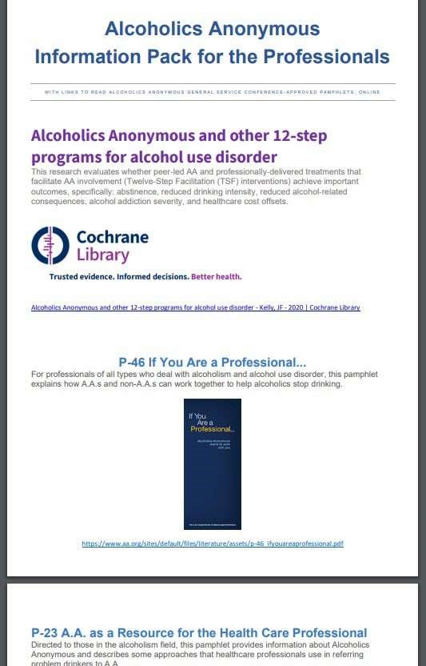

Notes:

TOPIC #020/2023: (Put Cochrane Report in Professionals' packs)

An adoption of the Cochrane report into AA literature Professionals pack to be approved for the purposes Public Information and working with the professional community.

WHAT IS THE BACKGROUND OR REASON FOR THE TOPIC?
- To enable PICPC committee to use the current professional opinion of the medical community in its efforts to carry the message.
- To help the Professional community of doctors and counselors etc. rest in the knowledge that sending those afflicted our way through faith in their own Peers.
- Help spread awareness of the scientific research made by the professional community supporting AA's process with the Alcoholic dilemma
- To help give families hope and faith in AA's solution, showing the scientific study backed by the medical profession.
- Education of current medical graduates unaware of the solution AA has to offer and the medical research undertaken by their Peers.
- To show the alcoholic sufferer the research taken already by the medical community placing faith in AA's 12step process and solution available.

DO YOU HAVE A SUGGESTED SOLUTION?
- Approval of the use of the Cochrane report into the literature pack handed out to professionals.
- Understanding that the professional community of today relies on scientific study and approach
•

HOW WILL THE ALCOHOLIC WHO STILL SUFFERS OR THE FELLOWSHIP OF ALCOHOLICS ANONYMOUS
BENEFIT FROM THIS SUGGESTION?
- Accurate up to date information supplied by the medical minds of today placing faith in AA's approach.
- Current medical graduates educated so that future alcoholics here of our means of recovery
- Less prejudice towards the fellowship as a whole given the assumption that there is no scientific proof
- An understanding that AA has the support of the medical community backed by Scientific research.
- The hope that less of our fellow sufferers will get lost in the medical industry unaware of AA's solution.

WHAT ARE THE ESTIMATED COSTS OF IMPLEMENTING THIS SUGGESTION?
No idea, assuming it's only the introduction of pdf files into forwarded literature through PI. The cost to the individual group should they wish to add the information.

HAVE YOU ASKED YOUR GROUP, DISTRICT OR AREA TO MAKE A DECISION ABOUT THIS TOPIC AND, IF
SO, WHAT WAS THE OUTCOME?
Yes
PICPC Committee, Motion Approved
District C Committee, Motion
Approved

Gold Coast District supports this topic.

Notes:

TOPIC #021/2023: (Reduce Delegates Term to 2 Years)

Conference Delegates term.
Suggest to Policy & Admissions Committee that Conference Delegates 3-year term be reduced back to a 2-year term.
WHAT IS THE BACKGROUND OR REASON FOR THE TOPIC?
- The current serving time is 3 years to Conference.
- This term does not align with the terms of: Area Secretary/Treasurer (2 years); Area Chair (2 years) Trustee (4 years), World Service (4 years) and is therefore out of step with other elected Trusted Servants.
DO YOU HAVE A SUGGESTED SOLUTION?
That Conference considers revisiting and re-examining the possibility of bringing Area Delegates in synch with their Area agendas and thus in line with the rest of service terms, saving much time and confusion and a smoother rotation.
HOW WILL THE ALCOHOLIC WHO STILL SUFFERS OR THE FELLOWSHIP OF ALCOHOLICS ANONYMOUS
BENEFIT FROM THIS SUGGESTION?
By bringing the delegates 3-year term to a 2-year one will possibly allow a more even flow of our delegates to other positions within our structure. Terms of service will be in accord with movement and stability within our service structure. Will create an ebb and flow within positions.
WHAT ARE THE ESTIMATED COSTS OF IMPLEMENTING THIS SUGGESTION?
The shared cost of travel would be reduced for all Areas.
HAVE YOU ASKED YOUR GROUP, DISTRICT OR AREA TO MAKE A DECISION ABOUT THIS TOPIC AND, IF
SO, WHAT WAS THE OUTCOME?
My prior involvement as a Delegate for Central region many years past has enabled me to make a comparison ;what it was like’, ‘what happened’ and ‘what it is like today’ on this debate. I am grateful that we have one more sober day.

Notes:

TOPIC #019/2023: (Shorten Class A Trustee Terms)

The General Service Board consider changing the current Class A Trustee term from 5 years to 3 years plus an optional 4th year plus an optional 5th year should the Class A trustee and the board wish to exercise one or both of those 1-year options.

WHAT IS THE BACKGROUND OR REASON FOR THE TOPIC?
- The change in term for our Class A trustees may assist us with attracting great candidates without diminishing to continuity of having a Class A Trustee onboard for a full 5 years.
- Even in the corporate space we are rarely asked to sign up to commitments for a 5year term. Is it possible that the long duration of the term deters candidates who are well qualified and would otherwise be interested?
- Class A Trustees are the much-needed public face of Alcoholics Anonymous and provide a valuable service to our Australian AA Fellowship. The past few years much of the work needed to be done by these valuable Trustees has fallen to one Class A Trustee (a second Trustee started their term in 2023 which is positive for our Board and Fellowship).

DO YOU HAVE A SUGGESTED SOLUTION?
- Stated in the topic. Should the board see merit in this, the term for a class A trustee would change from 5 years to 3 years, +1year, +1 year.

HOW WILL THE ALCOHOLIC WHO STILL SUFFERS OR THE FELLOWSHIP OF ALCOHOLICS ANONYMOUS
BENEFIT FROM THIS SUGGESTION?
- AA owes a debt of gratitude to the important work our Class A Trustees have performed for us over the years. They can often reach parts of the professional community that alcoholic members cannot. By making it as attractive as possible for these people to serve AA it helps our entire membership.
WHAT ARE THE ESTIMATED COSTS OF IMPLEMENTING THIS SUGGESTION?
A small number of administrative hours to make a change to the service manual in the section shown below.
Figure 1 Relevant Section of AA Australian Service Manual
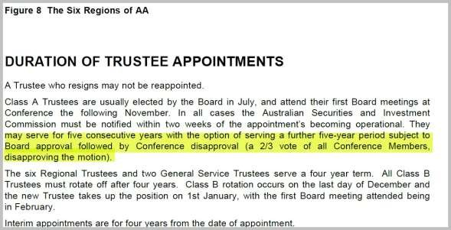
HAVE YOU ASKED YOUR GROUP, DISTRICT OR AREA TO MAKE A DECISION ABOUT THIS TOPIC AND, IF
SO, WHAT WAS THE OUTCOME?
Topic discussed at area 21/05/2023 and initially had numbers but minority opinion stated the manual already says “may serve” for 5 consecutive years and topic didn’t get a 2/3rds majority.

Topic discussed at Gold Coast District 23/05/2023 and had unanimous support. Feedback was shared that a recent applicant for a Class A trustee role felt that the 5-year term may hold applicants back from the role.

Notes:

TOPIC #022/2023: (Electronic 7th Tradition).

Our home group would like guidance from the GSO regarding electronic transfer of payments for 7th tradition, and suggested methods for home groups to facilitate this. We seek guidance on anonymity and legal/administrative issues with bank transfers, and prioritising allocation of funds to home group running costs before splitting the remainder to 60-30-10 (or 50-30-10-10).

WHAT IS THE BACKGROUND OR REASON FOR THE TOPIC?
- We are moving to a cashless society
- There are anonymity issues with using bank transfers to accounts hosted by the group treasurer
- There are continuity and paperwork issues required for opening bank accounts for home groups, including requiring formal minutes of group conscience meetings with members’ full names.
- If donating directly to the CSO, the home group does not receive those funds to cover their primary costs
- Anonymity and paperwork issues/difficulties involved with setting up a tap-and- go/paywave system
- 60-30-10 through the CSO uses up valuable office time that could be better used to serve the still suffering alcoholic, however we do not feel right in telling members how much they “should” donate to make the donation worthwhile.
DO YOU HAVE A SUGGESTED SOLUTION?
- A discussion on the following topics:
- Whether bank transfers breaks the anonymity principle
- Whether any of these proposed methods are in line with the spirit of the traditions
- Whether our CSO should be taking steps to facilitate easier accounting of 7th traditions donations
- Whether we should continue only accepting donations in cash form

HOW WILL THE ALCOHOLIC WHO STILL SUFFERS OR THE FELLOWSHIP OF ALCOHOLICS ANONYMOUS
BENEFIT FROM THIS SUGGESTION?
- A more consistent banking method for all groups to use to work together and with the CSO for ease of function
- Aids in a sense of unity where groups can make decisions based on experience/guidance/suggestions of older sober members and the General Service Conference

WHAT ARE THE ESTIMATED COSTS OF IMPLEMENTING THIS SUGGESTION?
A discussion will have no assumed costs.
There may be a cost associated with updating CSO accounting software.

HAVE YOU ASKED YOUR GROUP, DISTRICT OR AREA TO MAKE A DECISION ABOUT THIS TOPIC AND, IF SO, WHAT WAS THE OUTCOME?
Adelaide City Beginners have received the support of City & Eastern District and Area B for submission of this topic.

Notes:

TOPIC #023/2023: (Volunteers for Phone Line)

Conference to consider asking for volunteers from any location around Australia to assist in answering the 24-hour phone help line.

WHAT IS THE BACKGROUND OR REASON FOR THE TOPIC?
Area E Eastern Region has been providing a 24-hour phone service for years and has helped many alcoholics.
Currently, as we understand it, Area E Eastern Region is also taking calls diverted from other areas when they are not answered. Unfortunately, Area E Eastern Region is struggling to find enough volunteers to fulfil this essential service and as a result there are times when the phone goes unanswered.

DO YOU HAVE A SUGGESTED SOLUTION?
1. Create a nationwide roster of volunteers to answer calls. They can be simply added to Area E Eastern Region roster or coordinated some other way. This would not preclude anyone from volunteering in their own area.

HOW WILL THE ALCOHOLIC WHO STILL SUFFERS OR THE FELLOWSHIP OF ALCOHOLICS ANONYMOUS
BENEFIT FROM THIS SUGGESTION?
The still suffering alcoholic who calls the help line will have their call answered and get to speak to another alcoholic.

For many of us the help line has been our first point of contact with AA and has been essential in getting us into recovery.

WHAT ARE THE ESTIMATED COSTS OF IMPLEMENTING THIS SUGGESTION?
Nil, if we are simply adding new numbers to the existing roster

HAVE YOU ASKED YOUR GROUP, DISTRICT OR AREA TO MAKE A DECISION ABOUT THIS TOPIC AND, IF
SO, WHAT WAS THE OUTCOME?
Yes. This form was submitted to a meeting held on 18/04/2023 by the Northern Sydney Central Service Office (NSCSO) of Area E Eastern Region. It was discussed and a motion was passed to proceed with the proposal.
Yes. This form was submitted to Area E for their May meeting which unfortunately was cancelled. The chairperson recommended we proceed with submission and Area E would vote on it at the November Assembly.

Notes:

TOPIC #024/2023: (New PI Poster)

New Poster for PI/CPC to become conference approved. Created by member and posted on National PI/CPC WhatsApp Group

WHAT IS THE BACKGROUND OR REASON FOR THE TOPIC?
- Add to existing posters
- Will attract more suffering Alcoholics
- Encourage more designs and videos by our members using the apps available now

DO YOU HAVE A SUGGESTED SOLUTION?
Approved at Conference to be added to existing range of posters in PI/CPC

HOW WILL THE ALCOHOLIC WHO STILL SUFFERS OR THE FELLOWSHIP OF ALCOHOLICS ANONYMOUS
BENEFIT FROM THIS SUGGESTION?
- Add to existing range of Posters in PI/CPC
- Posters have Depth and weight to reach the still suffering
- Encourage PI/CPC within AA AUST.

WHAT ARE THE ESTIMATED COSTS OF IMPLEMENTING THIS SUGGESTION? Nil, Design, AA number and website attached A5 poster

HAVE YOU ASKED YOUR GROUP, DISTRICT OR AREA TO MAKE A DECISION ABOUT THIS TOPIC AND, IF
SO, WHAT WAS THE OUTCOME?
Posted on National PI/CPC WhatsApp group, feedback by those who commented was supportive and positive, Approved in Principle at Area

Notes:

TOPIC #025/2023: (Proposal for a Secular Leaflet).

PROPOSAL FOR A SECULAR AA LEAFLET
That the proposed leaflet (attached), directed to persons who are agnostic or atheist, be considered as approved AA literature for Australia distribution to AA offices and groups.
AA has listed worldwide secular AA meetings for decades. In comparison, secular AA meetings in Australia are relatively new with a steady increase in the number of meetings and attendees in recent years, both face to face and on-line. All are listed on the Australian AA website, where many discovered secular AA meetings by chance.
The awareness and visibility of secular AA groups in Australia requires enhancing. This leaflet is a succinct trifold, double-sided leaflet which has been designed for this purpose.

WHAT IS THE BACKGROUND OR REASON FOR THE TOPIC?
It is well documented that AA is not a religious organisation and has done much to foster the inclusion of ‘non-believers’ including secular information and meetings on AA websites, input at conventions and approved AA literature The “God Word’ and ‘One Big Tent’.

Whilst secular members do not seek to be separate from AA, the feeling of inclusion is not always present. There are still groups and individual members who cannot accept that AA can be beneficial and successful to those members who are uncomfortable with the idea of God or the concept of a higher power to keep them sober.
Agnostic and atheist members are less likely to initiate and sustain attendance at AA meetings where they do not feel included, which culminates in reticence to attend or be open and honest.
This leaflet recognises and encourages AA participation for alcoholics identifying as agnostic, atheist or of no religion.

DO YOU HAVE A SUGGESTED SOLUTION?
The widespread availability of this leaflet would be a straightforward and unambiguous effort to assure the newcomer that their beliefs, or lack thereof, need in no way preclude their membership of the Fellowship. The inclusion of direct quotes from Bill Wilson corroborates the message that AA is for everybody, that the steps are suggestions only and there is no religious or spiritual requirement for membership.

In addition, a suggestion to include this leaflet in Newcomer Packs would extend the program options to the struggling alcoholic.
HOW WILL THE ALCOHOLIC WHO STILL SUFFERS OR THE FELLOWSHIP OF ALCOHOLICS ANONYMOUS
BENEFIT FROM THIS SUGGESTION?
This leaflet is both an attraction and benefit to AA members.
- Whether they are a newcomer or a newcomer who is agnostic or atheist and is apprehensive and/or perhaps skeptical about attending AA
- For existing members who may not be aware of this type of meeting
- As a reminder to existing dogmatic members that there are choices and options
- As an insightful, educational tool to all members, particularly those who are ‘12 stepping’
- Provides an easy-to-follow guide on how to access a secular AA meeting.

WHAT ARE THE ESTIMATED COSTS OF IMPLEMENTING THIS SUGGESTION?
It will cost nothing to amend the design/text as I can do this. It was intentionally created as a single A4 double-sided, tri-fold sheet to reduce costs.
The attached leaflet was professionally produced at a cost of AUD 0.99cents by Officeworks.
The cost reduces with the quantity ordered (≤ 34cents).

HAVE YOU ASKED YOUR GROUP, DISTRICT OR AREA TO MAKE A DECISION ABOUT THIS TOPIC AND, IF
SO, WHAT WAS THE OUTCOME?
Being on-line I am unaware of a local district/Area, however feedback was sought from every listed Australian secular AA group with overwhelmingly positive remarks.

The proposed leaflet was introduced and welcomed in both ADL & QLD CSO’s. It was accepted and displayed on the literature table at the Perth convention.

Notes:

TOPIC #015/2023: (Need for a secular AA leaflet)

NEED FOR A SECULAR AA LEAFLET
It is proposed that the GSB create a modern leaflet covering the inclusion of people of secular beliefs in the AA Fellowship.
The need is twofold:

- To attract persons who are agnostic or atheist. Dispelling the myth that AA is all about God will provide a more accessible route to the program for some people. Other sub-groups have been the focus of concerted efforts across the fellowship in recent years.
- To show all members that secular members are to be encouraged and included and not discriminated against as has been the experience of a number of members in the last few years.

WHAT IS THE BACKGROUND OR REASON FOR THE TOPIC?
Secular meetings have been listed by AA both here and internationally for some time, but the space in listings to explain what a secular meeting is, is very limited and a leaflet of the proposed type would provide clarity for members or prospective members.

Existing AA literature The “God Word’ and ‘One Big Tent’ are important and useful books but are dated and written originally with a North American audience in mind.

As a self-proclaimed 100% inclusive society since foundation, to support the alcoholic who
is still suffering to engage with our fellowship we need a modern and short piece- to foster identification with us for atheist and agnostic potential members. Secular members are frequently made to feel that their recovery cannot be “real” or effective if they do not
“believe in God the same as everybody.”
This is clearly far removed from the spirit of alcoholics anonymous.

In Australia there has been little done to openly support secular membership, leaving some alcoholics in doubt as to whether AA is for them, and similarly other members unable to know how to support them, or indeed presenting the view that there is indeed no place in AA secular people. AA has always been inclusive and worked to remove barriers for attendance, indeed there are many famous writings by founder Bill W speaking to precisely this issue.

DO YOU HAVE A SUGGESTED SOLUTION?
Publishing a leaflet would encourage AA participation for alcoholics identifying as agnostic, atheist or of no religion. It will also show all members that non-believers should not be ‘shunned’ but can be encouraged to join and find their way to the recovery they need.

HOW WILL THE ALCOHOLIC WHO STILL SUFFERS OR THE FELLOWSHIP OF ALCOHOLICS ANONYMOUS BENEFIT FROM THIS SUGGESTION?
In the main, this leaflet would remove a barrier to many suffering alcoholics joining our fellowship and achieving the recovery they need.

This leaflet is both an attraction to any alcoholic who still suffers and a benefit to current AA members:

- Agnostic or atheist newcomers
- For current members who may not be aware of this type of meeting and meet someone of these beliefs in a 12th step context.
- Underline to those who wish to discriminate that it is not acceptable
WHAT ARE THE ESTIMATED COSTS OF IMPLEMENTING THIS SUGGESTION?
Unsure of cost to print, but the content could most likely be brought together by AA members with content knowledge and design/copywriting skills. We print a large selection of leaflets, so costs are likely to be the same as those already used.
Also the leaflets can be provided at small charge to AA entities as per existing leaflets.

HAVE YOU ASKED YOUR GROUP, DISTRICT OR AREA TO MAKE A DECISION ABOUT THIS TOPIC AND, IF SO, WHAT WAS THE OUTCOME?

Notes:

TOPIC #026/2023: (One Group, One Vote)

One group – one vote is the fundamental principle of Alcoholics Anonymous. This needs to be stated clearly in the AA Group Handbook.

WHAT IS THE BACKGROUND OR REASON FOR THE TOPIC?
At a recent forum workshop in Adelaide, when presenting the workshop on our
Traditions, I was asked a number of times why shouldn’t members belong to more than one Home group and vote at these groups? When I pointed out that so the home group is where we participate in the conscience of AA Australia, I was confronted by members who believed that it was ok to belong to more than one home group and vote at all the other home groups they claimed membership too.

DO YOU HAVE A SUGGESTED SOLUTION?
The statement to be put in the Group Handbook should clearly state that each member is entitled to choose one Home Group to belong to. At this group that member would have full voting rights but no voting rights at other groups which they attend. This does not include Districts, Areas and other service entities where the member is elected to fulfil. They have the normal voting rights at those service positions.

HOW WILL THE ALCOHOLIC WHO STILL SUFFERS OR THE FELLOWSHIP OF ALCOHOLICS ANONYMOUS
BENEFIT FROM THIS SUGGESTION?
One group – one vote is the fundamental principle of Alcoholics Anonymous that emphasizes the Importance of the democratic decision making and ensures that all members have an equal say in the organizational affairs of AA.
This principle is crucial to keeping AA united because it promotes a sense of equality and unity among members. AA is a Fellowship of the individuals who come together to share their experience, strength and hope with each other to overcome their alcoholism. Each member has an equal say in the organizational affairs regardless of their background, social status or level of sobriety by giving each member an equal vote. This will ensure that everyone’s voice is heard and that decisions are made within the best interests of the group. This process promotes transparency, accountability and cooperation which are essential for maintaining a healthy Fellowship.

WHAT ARE THE ESTIMATED COSTS OF IMPLEMENTING THIS SUGGESTION?
A simple statement could be put into an A4 sheet and inserted into all current Group Handbooks and emailed to each Central Service Office to insert in their respective copies. Estimated costs: $10- and 5-minutes work.

HAVE YOU ASKED YOUR GROUP, DISTRICT OR AREA TO MAKE A DECISION ABOUT THIS TOPIC AND IF SO, WHAT WAS THE OUTCOME?
My home group was supportive as well as the Brisbane District DCM.

Notes:

TOPIC #028/2023: (Resume Printing Service Manual and Guidelines)

Resume printing of the Australian AA Service Manual and the Guidelines
WHAT IS THE BACKGROUND OR REASON FOR THE TOPIC?
- The Australian AA Service Manual and the Guidelines were moved to an online PDF format for the Ninth Edition

- The decision was made to not issue and print a booklet, so that when updates were passed the whole service manual would not have to be reprinted. Updated pages could just be replaced.

- Printing and binding of the PDF both for the Australian Service Manual and Guidelines (220 pages) is nearly $80.

- To replace pages with comb binders is difficult to do and requires another visit to the printing agency.
Ring binders are suitable but difficult to transport and subject to opening and losing contents.

5 The weight of the printed pages is twice that of the books and is an issue when travelling on aeroplanes and other transport and while in other public situations.

6. Provides accessibility for offline and non-computer literate members.

DO YOU HAVE A SUGGESTED SOLUTION?
Reprint as books, with a revision to be made every five years or as required.

HOW WILL THE ALCOHOLIC WHO STILL SUFFERS OR THE FELLOWSHIP OF ALCOHOLICS ANONYMOUS BENEFIT FROM THIS SUGGESTION?
- Cost saving as books currently sell for around $30. 2.Lighter and easier to manage and transport.
- Ease of access to Service literature
- Further encourage the use of the Service Manual in Service work.

WHAT ARE THE ESTIMATED COSTS OF IMPLEMENTING THIS SUGGESTION? This needs to be quoted and will vary on quantities printed.

HAVE YOU ASKED YOUR GROUP, DISTRICT OR AREA TO MAKE A DECISION ABOUT THIS TOPIC AND, IF SO, WHAT WAS THE OUTCOME?
” In all our affairs” is an online meeting. No District or Area has been asked about this topic. This topic has been developed from members across Australia attending this meeting.
Some members are past and current Delegates, ex Trustees and the meeting Steering Committee.

Notes:

TOPIC #029/2023: (Dyslexic Font for Big Book)

Dyslexic Font for Big Book
Have copies of Alcoholics Anonymous (Big Book) printed for dyslexic people.

WHAT IS THE BACKGROUND OR REASON FOR THE TOPIC?
According to the International Dyslexia Association, as much as 15 to 20 percent of the U.S. population may have symptoms of dyslexia. Those include slow or inaccurate reading, weak spelling, and poor writing. While not all reading problems are caused by dyslexia, some of the same accommodations can help many struggling alcoholics. Using the best fonts for dyslexia is one way we can help.

Dyslexic people find it difficult to read the Big Book.

- There are dyslexic fonts that may be used to do a print of the Big Book for Dyslexic people.
- We would like the Alcoholics Anonymous book to be made readable to people with dyslexia.
- This may be a problem that keeps Dyslexic people out of AA.

DO YOU HAVE A SUGGESTED SOLUTION?
- Print a certain number of copies of Alcoholics Anonymous in a Dyslexia font type.
- Once the print is down to a certain number left in circulation. Have a trigger
amount to get more copies printed again in the Dyslexic Font.

HOW WILL THE ALCOHOLIC WHO STILL SUFFERS OR THE FELLOWSHIP OF ALCOHOLICS ANONYMOUS
BENEFIT FROM THIS SUGGESTION?
1.This will help the Alcoholics with dyslexia be able to read the Big Book and get an understanding of their problem and a solution to their problem.

WHAT ARE THE ESTIMATED COSTS OF IMPLEMENTING THIS SUGGESTION?
- I would not know the costs, but I would presume it may cost slightly more than the standard print of the Big Book as it uses:
- more ink because it has heavier line thickness at the bottom of most characters intended to better anchor letters
- and thicker or bolds capital letters and punctuations, to better identify where sentences start or end
- There is a dyslexic font (Gill Dyslexic) that you may have to purchase a license to use it, there is also another dyslexic font (OpenDyslexic) that is freely available to use at no cost.

HAVE YOU ASKED YOUR GROUP, DISTRICT OR AREA TO MAKE A DECISION ABOUT THIS TOPIC AND, IF SO, WHAT WAS THE OUTCOME?
I presented the topic at my home group, Common Welfare Recovery Group, Dandenong, Victoria on the 10/02/2023.

We came to the decision it was a great proposal and hope it can come to be of great help for dyslexic alcoholics.

Links to information on Dyslexic fonts:
These are good web pages with plenty of information on the different types of fonts available:
https://www.dyslexia-reading-well.com/dyslexiafont.html https://www.weareteachers.com/bestfonts-for-dyslexia/
This is a link to Open Dyslexic and is freely available for downloading for a dyslexic user. Our home group has used this for our run sheet for the meeting. It makes it much easier for the dyslexic members to chair the meeting.

OpenDyslexic is a free font and uses heavier bottoms and irregular shapes just like Dyslexie. Find out more about OpenDyslexic here.
https://opendyslexic.org/

This is a link to probably the best of the dyslexic fonts, but I can’t be the judge of this. May need professional and unbiased advice before one is chosen.

In Dyslexie, letters have heavier bottoms, slightly adjusted shapes, and longer sticks. This is a licensed font, and you’ll need to pay to use it in all your programs. Learn more about Dyslexie here. https://www.dyslexiefont.com/en/others/
This is a link to Dyslexia Association based in Australia. They may be able to help us with advice if we go ahead with the proposal.
https://dyslexiaassociation.org.au/

Notes:

TOPIC 030/2023: (Change to Service Manual)
Recommended change to Service Manual
As there has been some confusion regarding the meaning of the following paragraph from the Delegate Section of the Australian AA Service Manual (under the heading ‘About the Alternate Delegate’) , the Conference Policies & Admissions Committee requests that the Conference Report Charter and Service Manual Committee consider making the following recommendation to Conference.
That the following paragraph:
There are only two situations in which the Alternate Delegate can be seated at
Conference: - if there is an elected Delegate who, for some reason, is unable to attend Conference; and when the Delegate position is vacant. The Alt Delegate will be considered as having served one year as a Conference member and will only be permitted to attend two more Conferences in the Delegate position. (i.e. 3yrs)

be replaced by:

*A Delegate serves one term of three consecutive years. It is strongly recommended that a delegate serve a single term. An Alternate Delegate may, after attending one Conference in place of the Delegate, be elected to serve a full three-year term. (*please note, this is the wording used in the US/Canada Service Manual).

Notes:

TOPIC 031/2023 GUIDELINE # 39: (Virtual Area Guideline)

The Conference Policy and Admissions committee recommends that the current
Guideline #39 be replaced with the following below guideline below. . The reason for this recommended change is to clarify the guideline's intention that group GSRs reside in Australia. A group's GSR should be in a position to become a member of the Area
Committee, which requires them to be a legal resident, and/or become the elected Area Delegate or Alternate Delegate, which requires them to attend the general service conference in Australia.
VIRTUAL AREA GUIDELINE
For various reasons, some groups have decided to hold their meetings via cloud-based video communications apps rather than the traditional physical meetings. Should such groups wish to gather to form an online Area, the following process applies.
If the proposed Area wishes to become part of an existing region, they should submit the attached Form A to the Conference Policies & Admissions Committee. This is a slightly amended version of the form used by physical Areas.
Should the proposed Area wish to stand alone and not be part of an existing region, they should submit the attached form B to the Conference Policies & Admissions Committee. Such an Area would come under the auspices of the Trustees’ Remote Communities committee, with the Chair of this committee being available for consultation, etc.
The Area may choose to elect an Area Committee, consisting of an Area Delegate, Alternate Delegate, Chairperson, Secretary and Treasurer. All Area Committee members should live in Australia for the duration of their term of service. When electing an online group service representative (GSR) or an online Area Committee, members /groups are encouraged to consider the suggested qualifications as per Section 3 of the Service Manual.
The GSR is generally the group’s mail contact for the Australian General Service Office and usually assists with the planning of and/or attends regional forums and conventions in the Area. The GSR may be in line for election later as a DCM, Area Officer or Area Delegate. It is suggested you consider carefully whether your candidates are qualified in terms of experience and availability for the role.
Once the application to become part of the Australian General Service Conference Structure has been approved by Conference, the Area will be entitled to send their Delegate to the Australian General Service Conference. As for all other Areas, the cost equalisation levy will apply.

Please note:
Online-only groups belonging to, or considering joining, a virtual Area, should be hosted in Australia and their GSRs should ideally live in Australia.

Notes:

Attachment - Poster
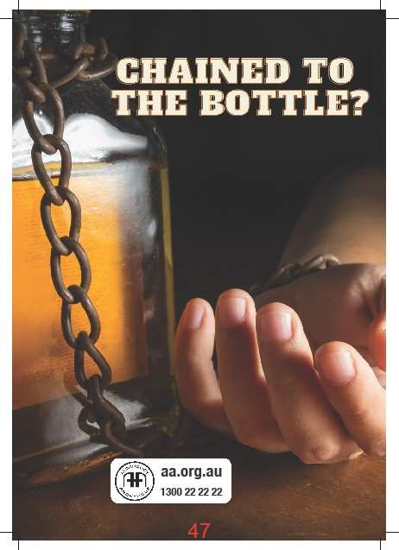

Attachment – Secular Leaflet
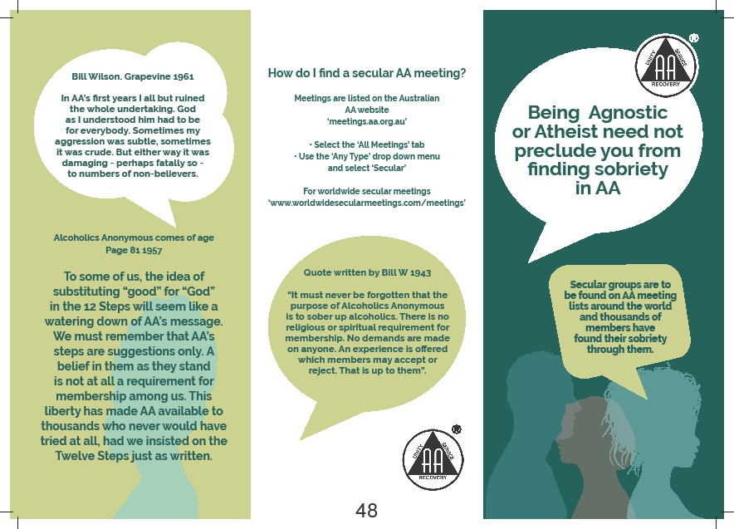

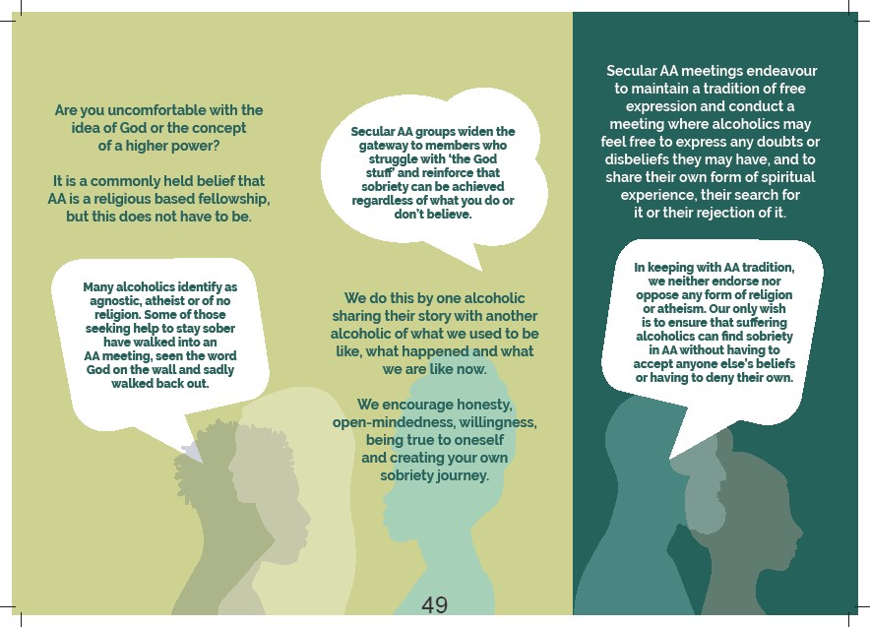

45

