 | The Serenity Times  The monthly newsletter of the Darwin District Office | November 2023

WELCOME BACK
Hello to all in recovery.  After a long period of absence it is with great pleasure that we announce the return of the Serenity Times.  This is your newsletter, and we welcome any submissions you would care to make. Please forward your announcements, articles, thoughts or events and we will do our best to include them in the next edition.  Darwin District Office  Contact us.  Nightcliff Community Centre  5/18 Bauhinia St  Nightcliff NT 0810  PO Box 40760  Casuarina NT 0801  Ph: 08 8948-5202  email: aa.darwin@bigpond.net.com  Website: aadarwin.org.au  If you would like to be placed on the mailing list for the Serenity Times, please contact the Central Service Office.  Step 11  “Sought through prayer and meditation to improve our conscience contact with God as we understood him, praying only for knowledge of His will for us and the power to carry that out”.  The 12 promises  - We are going to know a new freedom and a new happiness.  - We will not regret the past nor wish to shut the door on it.  - We will comprehend the word serenity.  - We will know peace.  - No matter how far down the scale we have gone, we will see how our experience can benefit others.  - That feeling of uselessness and self-pity will disappear.  Are these extravagant promises?  We think not. They are being fulfilled among us—sometimes quickly, sometimes slowly. They will always materialize if we work for them.  11th Step Prayer  Lord, make me a channel of Thy peace – that where there is hatred, I may bring love – that where there is wrong, I may bring the spirit of forgiveness – that where there is discord, I may bring harmony – that where there is error, I may bring truth – that where there is doubt, I may bring faith – that where there is despair, I may bring hope – that where there are shadows, I may bring light – that where there is sadness, I may bring joy.  O, Divine Master, grant that I may not so much seek to be consoled, as to console; to be understood as to understand; to be loved, as to love; for it is in the giving that we receive; it is in the pardoning that we are pardoned, and it is in dying that we are born to eternal life.  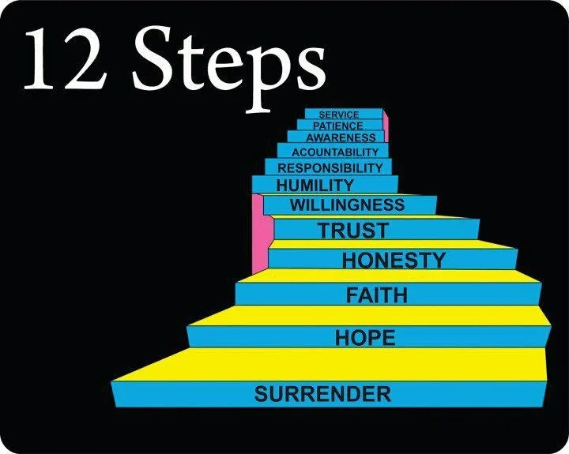  God grant me the serenity  To accept the things I cannot change;  Courage to change the things I can;  And wisdom to know the difference.  Meditation  Perhaps one of the greatest rewards of meditation and prayer is the sense of belonging that comes to us. We no longer live in a completely hostile world. We are no longer lost and frightened and purposeless. The moment we catch even a glimpse of God’s will, the moment we begin to see truth, justice, and love as the real and eternal things in life, we are no longer deeply disturbed by all the seeming evidence to the contrary that surrounds in purely human affairs.  p105 12 steps and 12 traditions. | Send your items to the Central Service Office via email and mark it to the attention of the Serenity Times Editor.  Your Darwin Committee  Kitty Kat Chair/DCM  Marg M Secretary  Matt DJ Office Registrar  Kate S Webmaster  Sam H Office co-ordinator Brendan A Literature Officer  Judelle Public Information  Darren H Treatment  Deb H Office Maintenance  Andy B Editor: Serenity Timesr  Tradition 11  “Our public relations policy is based on attraction rather than promotion; we need always maintain personal anonymity at the level of press, radio, and films” ¹²³. This tradition emphasizes the importance of anonymity in public relations and the need to avoid self-promotion. It is a reminder that personal ambition has no place in the organization and that the common welfare of all AA members should be placed before individual welfare.  - We will lose interest in selfish things and gain interest in our fellows.  - Self-seeking will slip away.  - Our whole attitude and outlook on life will change.  - Fear of people and economic insecurity will leave us.  - We will intuitively know how to handle situations which used to baffle us.  - We will suddenly realize that God is doing for us what we could not do for ourselves.  Vale Graham  A member who helped many find sobriety including his own during 30 years in Darwin, died recently. Graham R was 81; he had been sober 40 years.  Graham came to Darwin in 1969 and left to retire on the NSW south coast in 1999.  In the Territory he was very active in AA service. Both he and his wife Joan, who he married in 1983, encouraged people to do service. In NSW, almost to the end of his life, he was still involved in service.  Graham was a builder, who described himself as a bricklayer. He finished up working for NTEC, now Jacana.  Retiring to Ulladulla, Graham was a keen gardener, continued to support the English football team Manchester United and loved playing lawn bowls. For two years he was the top bowler at his club. Sadly, Parkinson’s disease put a stop to his bowls, but he continued to play mahjong, a mentally testing game.  Graham had been in hospital several times this year. He died on September 19 with his family around him. One of those who gave a moving eulogy at his funeral service was a young member he helped get sober.  Graham leaves wife Joan, three sons Vaughan, Aleric, and Derek and three grandchildren.  - Bob W  Service  Are you interested in increasing the amount of service you do?  If so, we are always after volunteers to help man the office, answer 12 step calls, attend rehabilitation meetings and more.  Service is one of the foundation stones of personal recovery. If you think you could be doing more, please reach out to a committee member or send an email to the office.  Until next time, stay strong.

