AREA A NORTHERN REGION
AREA COMMITTEE – Sunday 14 January 2024
FINANCIAL REPORT
The attached statement shows income and expenditure reconciled with the bank statements for the current Financial Year to date 01/07/2023 to 31/12/2023.
We currently have a balance of $5462.65. The balance includes a transfer from an unknown account of
$485.65 which is tagged as “Anonymous” pending investigation. The balance includes the 2023 Conference Levy of $1500 paid on 30 May (see last year’s report). Now that we are represented by our Delegate Doug, we will need to determine how much reserve we should maintain to meet our share of future annual Conference costs as determined by the GSB. Perhaps on a quarterly basis, if funds exceed the agreed reserve, the excess could be donated to the GSB.

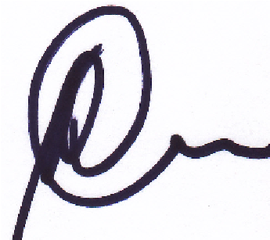
Pat Mac

Acting Treasurer Northern Region Area “A”

AREA A NORTHERN REGION - ACCOUNTS 1 JULY 2023 TO 30 JUNE 2024
Date Description Income |  | Expense | Balance
1/07/2023 Bank Account Balance as per statement |  |  | 4,386.03
6/07/2023 Tuesday Lunchtime | 25.82 |  | 4,411.85
8/07/2023 Wednesday Rapid Creek | 16.43 |  | 4,428.28
2/08/2023 Tuesday Big Book Recovery | 16.01 |  | 4,444.29
23/08/2023 Zoom Groups | 113.10 |  | 4,557.39
24/08/2023 Monday Daily Reflections | 31.15 |  | 4,588.54
24/08/2023 Bill W Camp | 100.00 |  | 4,688.54
31/08/2023 Tuesday Big Book Recovery | 25.23 |  | 4,713.77
27/09/2023 Tuesday Lunchtime | 31.35 |  | 4,745.12
2/10/2024 Wednesday Rapid Creek | 22.18 |  | 4,767.30
3/10/2024 Tuesday Big Book Recovery | 13.04 |  | 4,780.34
6/10/2024 Monday Daily Reflections | 20.00 |  | 4,800.34
17/10/2024 Saturday Womens Group | 63.65 |  | 4,863.99
2/11/2024 Tuesday Big Book Recovery | 17.35 |  | 4,881.34
12/11/2024 Zoom Groups | 90.00 |  | 4,971.34
30/11/2024 Anonymous | 485.65 |  | 5,456.99
5/12/2024 Tue | 5.66 |  | 5,462.65
 | ----------- | -----------
BANK RECONCILLIATION | 1,076.62 | 0.00
31/12/2023 Balance as per statement | 5,462.65
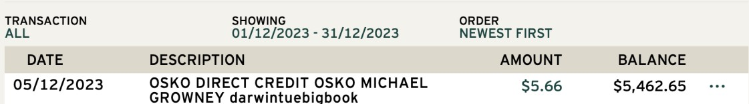

SUMMARY OF INCOME
Group Contributions
Tue | 5.66
Anonymous | 485.65
Bill W Camp | 100.00
Monday Daily Reflections | 51.15
Saturday Womens Group | 63.65
Tuesday Big Book Recovery | 71.63
Tuesday Lunchtime | 57.17
Wednesday Rapid Creek | 38.61
Zoom Groups | 203.10
Grand Total | 1076.62

