 | 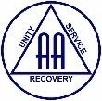  The Serenity Times  The monthly newsletter of the Darwin District Office | January 2024

Darwin District Office  Contact us.  Nightcliff Community Centre  5/18 Bauhinia St  Nightcliff NT 0810  PO Box 40760  Casuarina NT 0801  Ph: 08 8948-5202  email: aa.darwin@bigpond.net.com  Website: https://aadarwin.org.au  The website has lots of information:  - meetings  - Workshops  - Hints and tips  - Area for newcomers  - Articles  - DDO minutes and reports  - News  - Useful links  -And more.  If you would like to be placed on the mailing list for the Serenity Times, please contact the Central Service Office.  Step 1  “We admitted we were powerless over alcohol— that our lives had become unmanageable.”.  The 12 promises  1/. We are going to know a new freedom and a new happiness.  2/. We will not regret the past nor wish to shut the door on it.  3/. We will comprehend the word serenity.  4/. We will know peace.  5/. No matter how far down the scale we have gone, we will see how our experience can benefit others.  6/. That feeling of uselessness and self-pity will disappear.  7/. We will lose interest in selfish things and gain interest in our fellows.  8/. Self-seeking will slip away.  9/. Our whole attitude and outlook on life will change.  10/. Fear of people and economic insecurity will leave us.  11/. We will intuitively know how to handle situations which used to baffle us.  12/. We will suddenly realize that God is doing for us what we could not do for ourselves.  Are these extravagant promises?  We think not. They are being fulfilled among us—sometimes quickly, sometimes slowly. They will always materialize if we work for them.  BOOK REVIEW SERENITY TIMES JAN 2024  THE AUSTRALIAN SERVICE MANUAL Conference Approved.  Or could also be titled  “Alcoholics Anonymous 101”  https://members.aa.org.au/servicemanual/  If you have ever wondered how AA works and who is who, who does what and why and what does Conference, GSR, DCM, Area, CSO, District, PI&CPC, WSM ,AOSM all mean and then found yourself asking the question “ what do they mean by upside down triangle”, I even know a group who has a SMTM (Saturday morning toast maker- it’s a breakfast meeting) but you won’t find that one in the Australian Service Manual but you will find answers to just about everything else.  The Service Manual has a comprehensive yet condensed history, both USA and Australian AA- from the Conference Plan to Jack Alexanders article on AA.  It then proceeds to the practical descriptions and operations of daily AA operations such as “the AA group”, and the GSR. All practical and relevant information and suggestions born through AA experience.  Did you know that:  CONFERENCE - APPROVED LITERATURE  This is that literature which contains our message as it is understood by the Fellowship as a whole - the Message of the Three Legacies of Recovery, Unity, and Service. It is written for the sole purpose of preserving and carrying our message to the Alcoholic that ..  Service  Are you interested in increasing the amount of service you do?  If so, we are always after volunteers to help man the office, answer 12 step calls, attend rehabilitation meetings and more.  Service is one of the foundation stones of personal recovery. If you think you could be doing more, please reach out to a committee member or send an email to the office. | Send your articles and announcements to the Central Service Office via email and mark it to the attention of the Serenity Times Editor.  Your Darwin Committee  Kitty Kat Chair/DCM  Marg M Secretary  Elina Treasurer  Matt DJ Office Registrar  Kate S Webmaster  Sam H Office co-ordinator Brendan A Literature Officer  Judelle Public Information  Darren H Treatment  Deb H Office Maintenance  Andy B Editor: Serenity Times  r  Tradition 1  “Our common welfare should come first; personal recovery depends upon A.A. unity.”  First Step Prayer  Dear Lord, I admit that I am powerless over my addiction. I admit that my life is unmanageable when I try to control it. Help me this day to understand the true meaning of powerlessness. Remove from me all denial of my addiction¹  God grant me the serenity  To accept the things I cannot change.  Courage to change the things I can;  And wisdom to know the difference.  Cont..  still suffers or enabling it to be carried. This Category 1 literature is the one instrument by which we can be sure to remain one fellowship, with one message throughout, the world and into the future, regardless of language and cultural differences. It is that reference point that any alcoholic, wherever he or she may be in the world, can return to and be sure that what is written is the spiritual message of AA, and it can be trusted in every word to be a true guide. The Seal of Conference Approval is the Guarantee of that truth and trustworthiness.  NON-AA LITERATURE. Several books, which are published by outside organisations and therefore are not AA literature, are sometimes seen around AA meetings. Even though they may refer to AA and its program this does not mean they are AA literature. Many members find them useful personally and gain special insights when reading them. However, it should be realised that they do not contain the AA message in its fullness because they are expressions of individual opinion that have had no AA scrutiny or approval. Every AA member is at liberty to read any literature, of course. For an AA Group, however, to sell, endorse or promote literature from other outside enterprises is not in the best interests of either our Fifth or Sixth Traditions. Our primary purpose, as a Group, is to carry our Fellowship’s message.  Interested in the Legal structure of AA, copyright, use of AA symbols, AA international and Australia’s role?  Get you highlighter and ruler out for the most transparent, comprehensive journey into AA.  I mean really, did you think that AA was here just waiting for you and was and will always be here??? This manual tells me how to ensure that AA will be here for the next hopeless drunk, just like me. AND IT IS FREE. See the above link.  Mick G  Classifieds  For sale – ex DDO office printer.  $50.00. It works fine.  If interested, send an email to the DDO.  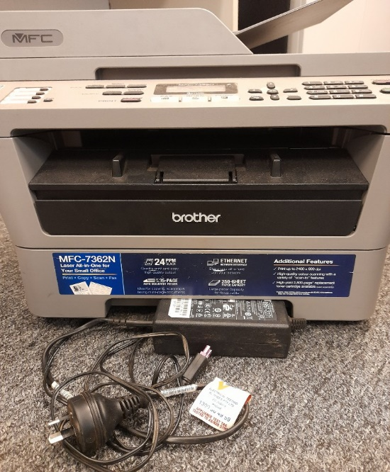
A day at a time  Even after many years sober, my recovery remains one day at a time. It was essential in early recovery and remains important to this day. The day at a time concept ensures:  - I break my sobriety into bite size chunks. One doesn’t eat an elephant in one meal, one does it over time. | - Life’s stressors can be managed more readily a day at a time and allows me to simply get through the day without a drink and reset tomorrow.  - It encourages mindfulness and it helps keep my head where my hands are.  This has worked for me and millions of others in recovery.  Until next time, stay strong. Ed.

